
Lab #8 Summer 2018

60-212 OOP Using Java

School of Computer Science,

University of Windsor

Due: Monday, July 30th, 2018 at noon.

Note: To submit your assignment (and all other assignments/labs), create a zip with all source files (.java, NOT .bin!!) and any other necessary files (for instance, input files), and submit it on Blackboard. If the solution is only one file, zipping is not necessary. Your submission will only be graded if you attended lab the week this was assigned.

10 Marks, 2% of grade

In this lab, you will create a GUI application that allows a user to move and resize a rectangle on the screen. The rectangle is initially red. If the user drags the top or left side of the rectangle, the rectangle should turn green and move with the mouse cursor. Movement should stop when the mouse is released, and the rectangle should go back to its original red colour. If the user drags the bottom or right side of the rectangle, the rectangle should turn blue and be resized using the edge being dragged. You need not handle a case where the bottom edge is dragged through the top edge, or the right edge is dragged through the left edge. When the mouse is released, resizing should stop and the rectangle should go back to its original red colour. I have provided some code to get you started.

Screenshots:

Original configuration, and while mouse button is not held down:

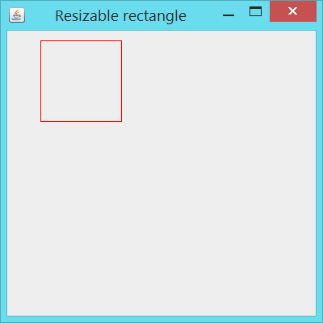

During a drag of top or left side:

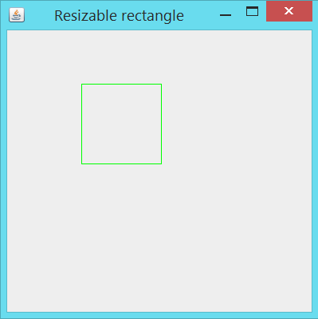

During a drag of bottom or right side:

